By:
Kylah irvin st10435066
Sivikelwe Nxumalo ST10448374
WEB DEVELOPMENT POE: pART 2
WEDE602
Pastimes Prototype documentation

POE Requirement documentation:

5.
--
-- Table structure for table `admin`
--

CREATE TABLE `admin` (
`adminId` int(11) NOT NULL,
`adminName` varchar(100) DEFAULT NULL,
`adminEmail` varchar(100) DEFAULT NULL,
`password` varchar(255) DEFAULT NULL
) ENGINE=InnoDB DEFAULT CHARSET=utf8mb4 COLLATE=utf8mb4_general_ci;

-- --------------------------------------------------------

--
-- Table structure for table `cart`
--

CREATE TABLE `cart` (
`cartId` int(11) NOT NULL,
`userId` int(11) DEFAULT NULL
) ENGINE=InnoDB DEFAULT CHARSET=utf8mb4 COLLATE=utf8mb4_general_ci;

-- --------------------------------------------------------

--
-- Table structure for table `cartitem`
--

CREATE TABLE `cartitem` (
`cartItemId` int(11) NOT NULL,
`cartId` int(11) DEFAULT NULL,
`productId` int(11) DEFAULT NULL,
`quantity` int(11) DEFAULT 1
) ENGINE=InnoDB DEFAULT CHARSET=utf8mb4 COLLATE=utf8mb4_general_ci;

-- --------------------------------------------------------

--
-- Table structure for table `category`
--

CREATE TABLE `category` (
`categoryId` int(11) NOT NULL,
`categoryName` varchar(50) NOT NULL
) ENGINE=InnoDB DEFAULT CHARSET=utf8mb4 COLLATE=utf8mb4_general_ci;

-- --------------------------------------------------------

--
-- Table structure for table `message`
--

CREATE TABLE `message` (
`messageId` int(11) NOT NULL,
`productId` int(11) DEFAULT NULL,
`senderId` int(11) DEFAULT NULL,
`receiverId` int(11) DEFAULT NULL,
`content` text DEFAULT NULL,
`timestamp` datetime DEFAULT current_timestamp()
) ENGINE=InnoDB DEFAULT CHARSET=utf8mb4 COLLATE=utf8mb4_general_ci;

-- --------------------------------------------------------

--
-- Table structure for table `order`
--

CREATE TABLE `order` (
`orderId` int(11) NOT NULL,
`userId` int(11) DEFAULT NULL,
`totalAmount` decimal(10,2) DEFAULT NULL,
`orderStatus` varchar(20) DEFAULT 'Pending',
`orderDate` timestamp NOT NULL DEFAULT current_timestamp()
) ENGINE=InnoDB DEFAULT CHARSET=utf8mb4 COLLATE=utf8mb4_general_ci;

-- --------------------------------------------------------

--
-- Table structure for table `orderitem`
--

CREATE TABLE `orderitem` (
`orderItemId` int(11) NOT NULL,
`orderId` int(11) DEFAULT NULL,
`productId` int(11) DEFAULT NULL,
`priceAtPurchase` decimal(10,2) DEFAULT NULL
) ENGINE=InnoDB DEFAULT CHARSET=utf8mb4 COLLATE=utf8mb4_general_ci;

-- --------------------------------------------------------

--
-- Table structure for table `product`
--

CREATE TABLE `product` (
`productId` int(11) NOT NULL,
`userId` int(11) DEFAULT NULL,
`brand` varchar(100) NOT NULL,
`price` decimal(10,2) NOT NULL,
`condition_score` int(11) DEFAULT NULL CHECK (`condition_score` between 1 and 5),
`description` text DEFAULT NULL,
`size` varchar(50) DEFAULT NULL,
`material` varchar(50) DEFAULT NULL,
`color` varchar(50) DEFAULT NULL,
`status` enum('Available','Sold') DEFAULT 'Available',
`datePosted` timestamp NOT NULL DEFAULT current_timestamp()
) ENGINE=InnoDB DEFAULT CHARSET=utf8mb4 COLLATE=utf8mb4_general_ci;

-- --------------------------------------------------------

--
-- Table structure for table `user`
--

CREATE TABLE `user` (
`userId` int(11) NOT NULL,
`userName` varchar(100) NOT NULL,
`userEmail` varchar(100) NOT NULL,
`password` varchar(255) NOT NULL,
`userAdress` text NOT NULL,
`role` enum('Seller','Buyer','','') NOT NULL,
`isVerrified` tinyint(1) NOT NULL DEFAULT 0,
`theme` enum('Light','Dark','') NOT NULL DEFAULT 'Light'
) ENGINE=InnoDB DEFAULT CHARSET=utf8mb4 COLLATE=utf8mb4_general_ci COMMENT='//the user table';

6. Below are screenshots of the necessary text files.
Admin Data:
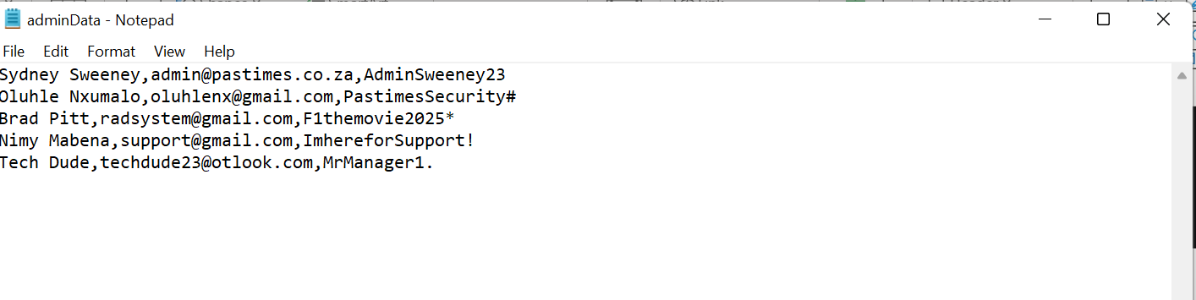
Category Data:
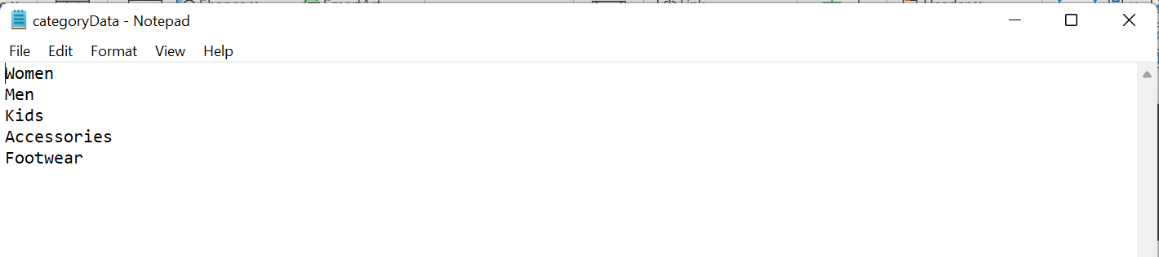
Product Data:
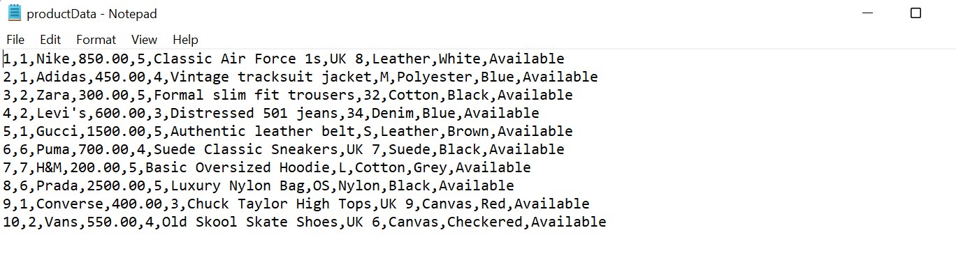
User Data:
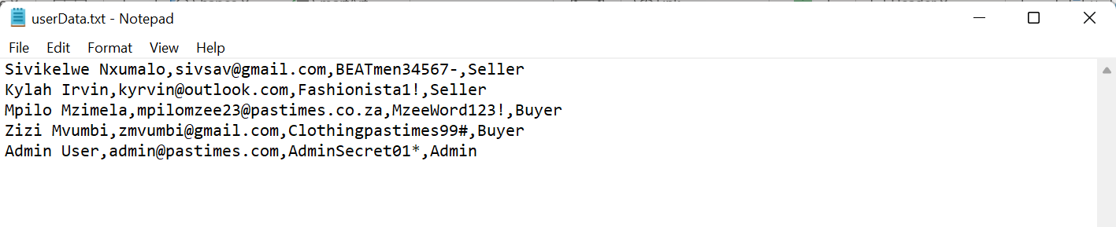

7. Below are screenshots of the process of importing the text files into phpMyAdmin.
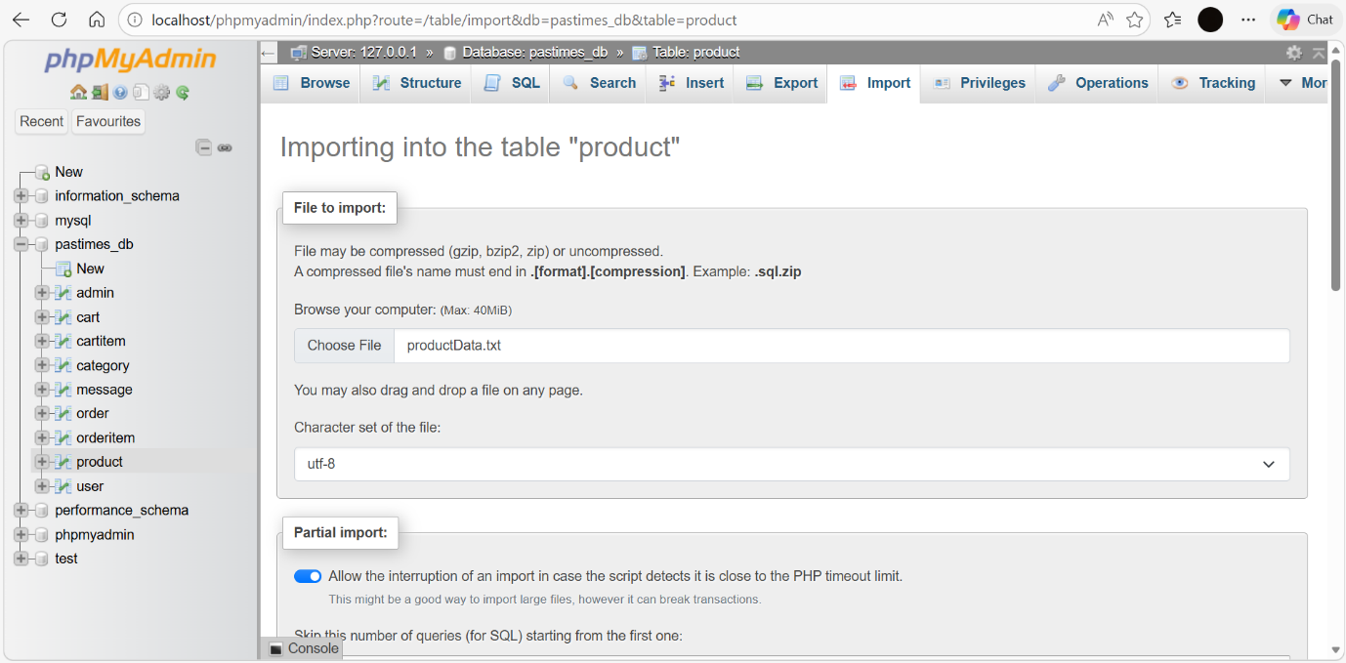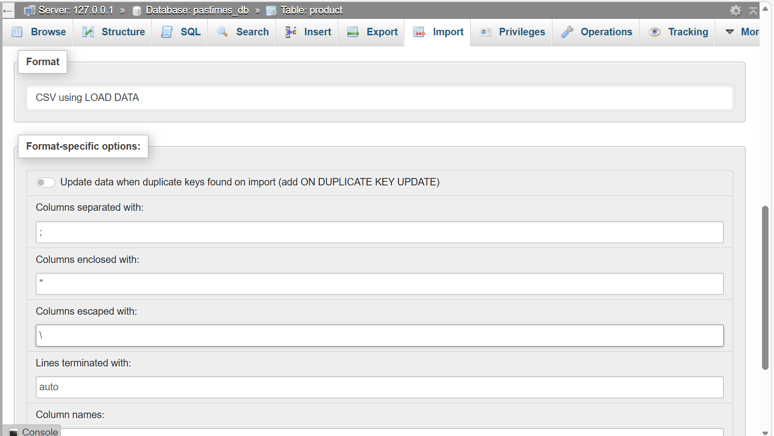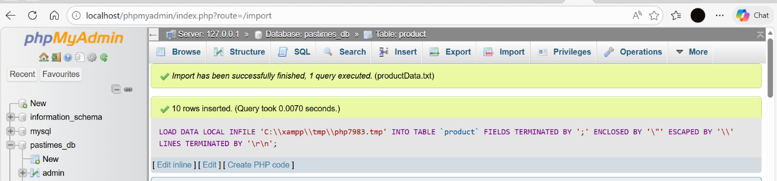
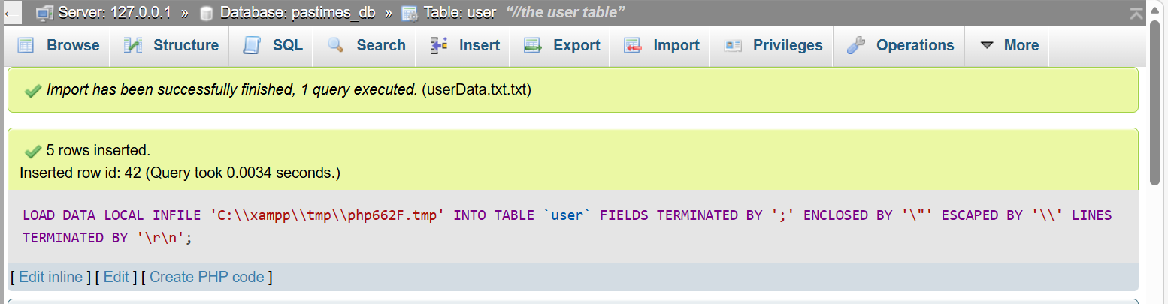
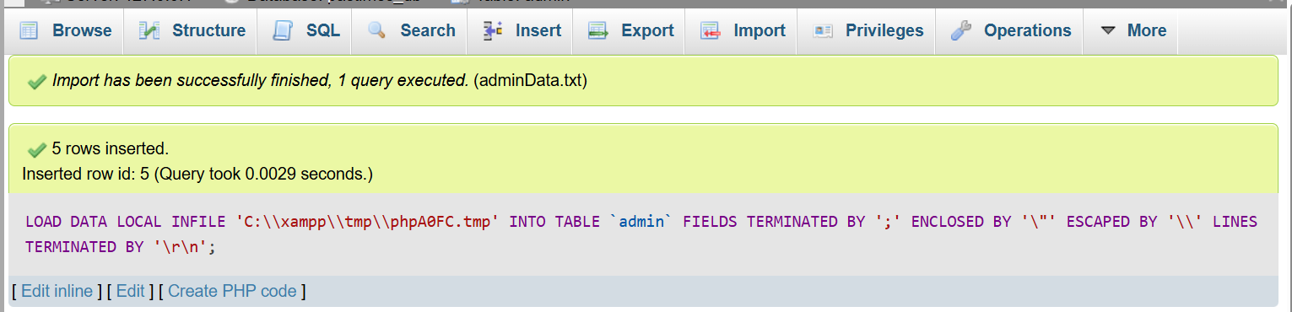

8. Below is a screenshot of the myClothingStore.sql in the pastimes folder in Visual studio:
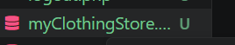

9. Below is the screenshot of the result of requirement 9.